Jake Murphy

November 09, 2019

IT FDN 100

Assignment05

**Lists and Dictionaries**

Contents

Introduction 2

Outline 2

Operation 3

Menu: 3

Show current task list 3

Add a new task 4

Remove an existing task 4

Save Data to File 4

Exit Program 5

Summary 5

Script 6

# Introduction

This intent of this paper is to describe the procedures used in successfully performing this assignment.

# Outline

Given a “Starter-file” provided by the instructor, and building off the last four assignments, we (the students) are to create a new project in PyCharm that manages a “To Do List”. The list manages a user inputted table containing a task and priority column. We (the students) were to modify the starter-file in such a manner that would provide a clear and error free program.

The program presents the user with five options:

1. Show current data
2. Add a new item
3. Remove an existing item
4. Save data to file
5. Exit program

# Operation

### Menu:

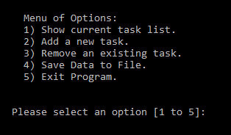

When the program launches, the user is prompted with a menu with five options.

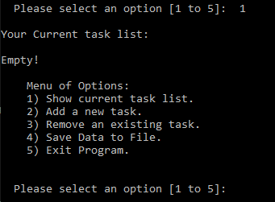

### Show current task list

If the user selects option 1, they are presented with one of two screens. If there is currently an empty task list, the user will see this screen.

If the task list is empty, the user is prompted with

“Your Current task list:

Empty!”

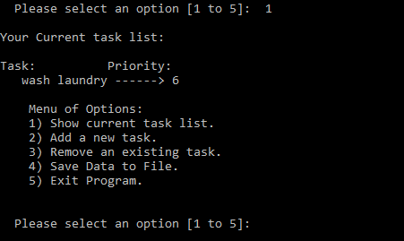

If the task list contained any data, the user would be presented with the following.

### Add a new task

If the user wishes to add a new task to the to-do-list, they are presented with the following

### Remove an existing task

In the event a user has completed or entered a task incorrectly, they have the ability to delete the task based on its task name and then priority level. They also are presented with the option to delete another task, or continue back to the main menu

### Save Data to File

Once the user has completed entering their tasks and priority levels, they may selection option 4 and save the data to the To-Do-List.txt file.

### Exit Program

Finally, the user may select to exit the program (preferably after they have saved the data to the file) they will also be asked if they are sure they want to exit. If they wish to not exit, they will return to the main menu.

# Summary

This assignment was challenging in its own rights. For some it was probably the easiest one yet, for others (like me) it became increasingly easier to get held up on something simple like using a list vs a dictionary. The possibilities of this application have already been put into use around my house, and I can’t wait to build from this assignment.

# Script

